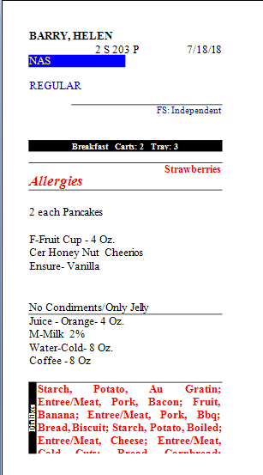
BARRY, HELEN
2 S 203 P NAS
7/18/18
REGULAR
FS: Independent
Breakfast Carts: 2 Trr: 3
Strawberries
Allergies
2 each Pancakes
F-Fruit Cup - 4 Oz. Cer Honey Nut Cheerios Ensure-Vanilla
No Condiments Only Jely Juice - Orange - 4 Oz. M-Milk 2% Water-Cold- 8 OZ. Coffee - 8 Oz
Starch, Potato, Au Entree/Meat, Pork, Bacon; Fruit, Banana; Entree/Meat, Pork, Bbq; Bread, Biscuit; Starch, Potato, Boiled; Entree/Meat, Cheese; Entree/Meat,
Dond Chand.

